Practice UNIT 5
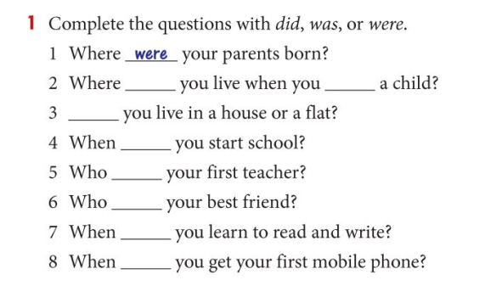
2 Write the past form of these verbs
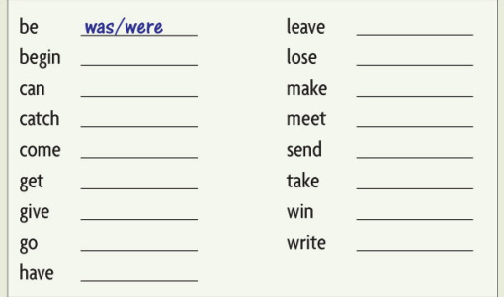
3 Compose 10 sentences in Past Simple Tense using the verbs from Ex.2
4 Read about Ben Way. What were his ups and downs? Open the parenthesis.
